Practical no 7
Code:-
text=str(input("Enter ypur paragraph:")).lower()
character=len(text)
spaces=text.count(" ")
words=len(text.split())

vowels="aeiou"
vowel_count=0
for i in text:
if i in vowels:
vowel_count+=1

print("\n===========text analiyse===============")
print("Total character",character)
print("Total spaces:",spaces)
print("Total wors:",words)

if len(text)>0:
print("first character (indexing):",text[0])
print("last character (indexing:)",text[-1])

print("first 10 character (slicing):",text[:10])
print("last 10 character (slicing):",text[-10:])
Output:-
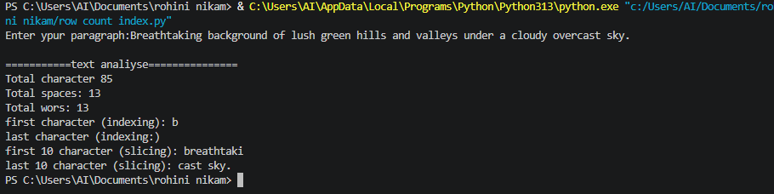

Exercises
Q1.Develope an automated email scanner that checks a text block to count occurrence of special symbol charaters (such as @,..,and!)
Code:-
text = input("Enter the email text :" )

at_count = 0
dot_count = 0
exelimation_count = 0

for ch in text:
if ch == "@":
at_count += 1
elif ch == ".":
dot_count += 1
elif ch == "!":
exelimation_count += 1

print("\n------EMAIL SCANING RESULT-------")

print("@ symbols",at_count)
print(". sumbols",dot_count)
print("! symbols",exelimation_count )
Output:-

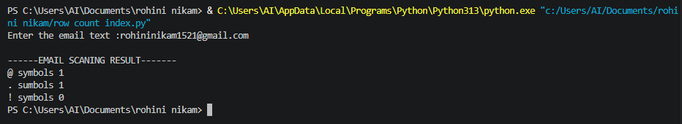

Q2.Create a word counter utility that counts how many times the word python appears in a user submitted paragraph ,ingonring case variation.
Code:-
paragraph = input("Enter a paragraph...")
count = paragraph.lower().split().count("python")

print("The word 'python' appears ",count,"times")
output:-
